practice 1：

Calculate Reflection Coefficient at the load using matlab

*Members: Zhi Han, Renzhou Ge, Juncheng Hu, Manlin Liu, Duo Wang*

task:

Draw a diagram of formula ΓL =( ZL - Z0)/( ZL + Z0) for ZL / Z0 is in the area of [0,1] and [1,100].

solve:

First, create a file 'calculate_gama.m' to define a function:

function [y] = calculate_gama(x)

y = (x -1) ./ (x + 1);

end

Then, create the file 'plot_gama.m'. Print the figure. The code is:

x1=linspace(0,1);

x2=linspace(1,100);

subplot(1,2,1);

plot(x1,calculate_gama(x1));

hold on

subplot(1,2,2);

plot(x2,calculate_gama(x2));

hold off

The figure we got is following:

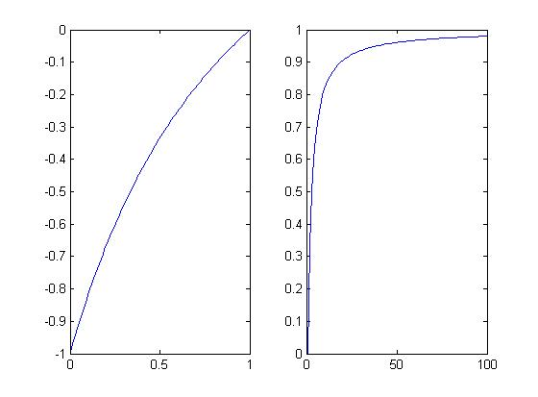

We can use 'insert' to change the sign of X coordinate and Y coordinate. Finally we can get the picture as following:

